The detection of the exoplanet Kepler-17 b of the star system Kepler-17 using the transit method, whilst accounting for stellar variability

Abstract
Time-series photometry from the Kepler Space Telescope was analysed in order to identify the properties of the Kepler-17 system. A refined model of the transit method was undertaken, which not only included the planetary transit but also the stellar variability of starspots on the stellar surface, which would affect the flux received by the telescope.
As a light curve could be produced, the orbital period of Kepler-17 b and the stellar rotation of Kepler-17 were determined from a periodogram with a Gaussian fitting.
Various transit events were isolated and normalised using a linear fitting to calculate the radius ratio between the star Kepler-17 and the exoplanet Kepler-17 b, Rp​/R⋆​.
The results show that the changing and evolving stellar surface affects the light curve, producing dips in brightness which must be accounted for when attempting to find an accurate value for the parameters of the Kepler-17 system.

Introduction
Detecting exoplanets using the transit method relies on measuring the brightness/flux of a star over a period of time. Any dips in brightness would be caused by a transiting planet that blocks a certain amount of light from the star to reach whatever device is recording the flux, resulting in the star appearing dimmer at specific points in time. These dips in brightness can be used to calculate key parameters about the star and the orbiting exoplanet.

However, just because there is a decrease in flux/light observed doesn’t guarantee the detection of an exoplanet orbiting around the observed star. Sunspots or star spots for a star that isn’t the sun could be the cause of this.

Stars have an intense magnetic field due to a process called the stellar dynamo, causing large-scale magnetic fields that can emerge on the surface and can result in star spots, solar flares and solar winds. Due to these star spots constantly changing, many stars will have quasi-periodic variations due to star spots rotating with the stellar surface as the star rotates. This can cause a complication in data and make it more difficult to interpret and identify an exoplanet via the transit method.

Star spots are points along the star where there is an intense magnetic field, resulting in blocking the outward flow of heat from the star’s interior, causing a decreased temperature at various points. This decreased temperature causes the intensity of light emitted from that point to decrease as well, which, if observed, would result in the star appearing dimmer than if it had no star spots. And according to Wien’s law, cooler objects emit peak energy at lower frequencies and longer wavelengths.

The peak wavelength of emission from a star is given by Wien’s law:



As darker areas have a lower temperature, Wien’s law therefore explains why these cooler starspots on a star appear darker than the surrounding area.

Whilst performing the experiment, the aim was to:
- Obtain a value for the orbital period, P_{orb}, for the exoplanet Kepler-17 b that orbits its host star Kepler-17
- Obtain a value for the rotation period, P_{rot}, of the host star Kepler-17
- Obtain a value for the radius ratio, R_{p} / R*, between the planet Kepler-17 b and its host star Kepler-17
- Evaluate the impact of starspots on the stellar surface of a star, which causes stellar variability
Hypothesis – incorporating star spot-induced variability would result in significantly improved model agreement with the observational data and provide more accurate readings of the parameters.

Observations and data

The data that was analysed within this experiment was obtained from the NASA Exoplanet Archive, which can be found on any search engine. Data for Kepler-17 were obtained from the Kepler Space Telescope.

From the NASA Exoplanet Archive, two datasets were used:
- Quarter 5 long cadence light curve, allowing for analysis of the stellar surface variability and periods
- Quarter 4 short cadence light curve, allowing us to perform transit fitting
The data used consisted of time-series photometry, which recorded the star's flux or brightness as a function of time. This data would allow for graphs to be produced, which could be analysed, and the times of transit of the planet when orbiting in front of the star from our perspective, as these periods would have a constant time period, could be identified. Additionally, being able to identify the times when star spots appear on the stellar surface and reduce the observed brightness, as they have quasi-periodic variations.

Additionally, data was collected from the NASA Exoplanet Archive, providing useful information on Kepler-17 and Kepler-17 b, which can be found in Table 1.

Table 1: A table comprised of data found on the NASA Exoplanet Archive of the Kepler-17 star system.
Data type | Data value | Data uncertainty | Unit | Source
M⋆ | 1.16 | ± 0.060 | Solar masses | Bonomo et al. 2017
R⋆ | 1.050 | ± 0.030 | Solar radii | Bonomo et al. 2017
P rot | 12.01 | ± 0.16 | Days | Bonomo et al. 2017
P_{p} | 1.4857108 | ± 0.0000002 | Days | Desert et al. 2011
R_{p}/R⋆ | 0.13031 | +0.00022, -0.00018 | - | Desert et al. 2011
a | 0.02591 | +0.00037, -0.00036 | Astronomical unit, au | Desert et al. 2011

Method

Theoretical model:
The initial model of the system assumed that the stellar surface would maintain a constant brightness, and the only periodic dips that would occur would be when a planet transits in front of the star.

However, there are other factors that need to be included in order for the model to be more accurate and realistic. Stellar rotation and star spots can cause quasi-periodic variations in the brightness of the star. This results in dips in brightness on the light curve, not just the transit of a planet around the star, but instead a variation of brightness emitted from the stellar surface due to starspots being present and rotating in and out of the observer’s view.

Figure 1: A schematic diagram of a planet transiting its star, Kepler-17 b transiting Kepler-17, producing periodic dips in brightness. Starspots on the stellar surface produce quasi-periodic variations in brightness as the star rotates about its axis. The dashed line indicates the transit path, and the curved line indicates the rotation of the star that it takes upon its axis relative to the observer.

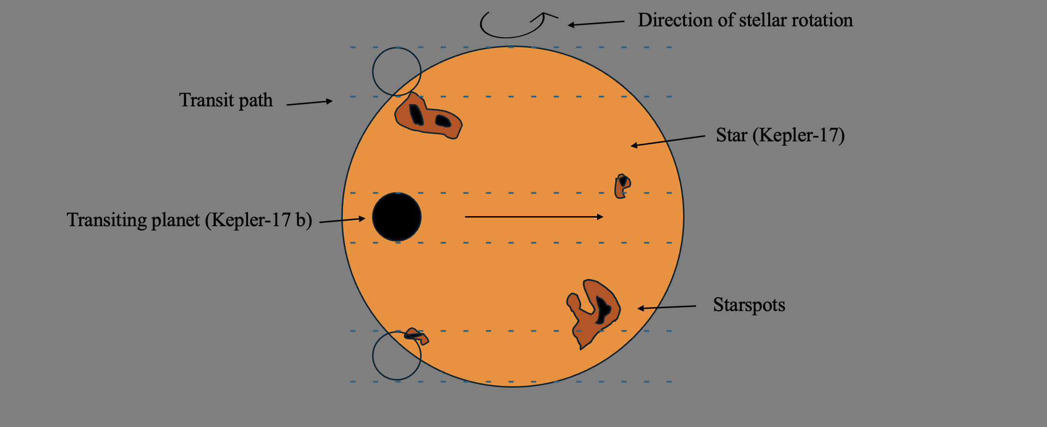

Light curve analysis:

The light curve was plotted from the quarter 5 dataset. This was done by downloading the light curve data from the NASA Exoplanet Archive and importing it into the programming language Python.

The time and flux values were plotted using Matplotlib, with time on the x-axis and flux on the y-axis. This produced a light curve of the star Kepler-17’s brightness as a function of time. As this light graph was produced, figure 2, dips in the light curve could be analysed to determine whether they were caused by a transiting exoplanet or starspots on the stellar surface.

Figure 2: A graph showing the flux that was observed by the Kepler Space telescope when analysing the star Kepler-17, producing a light curve with flux being a function of time
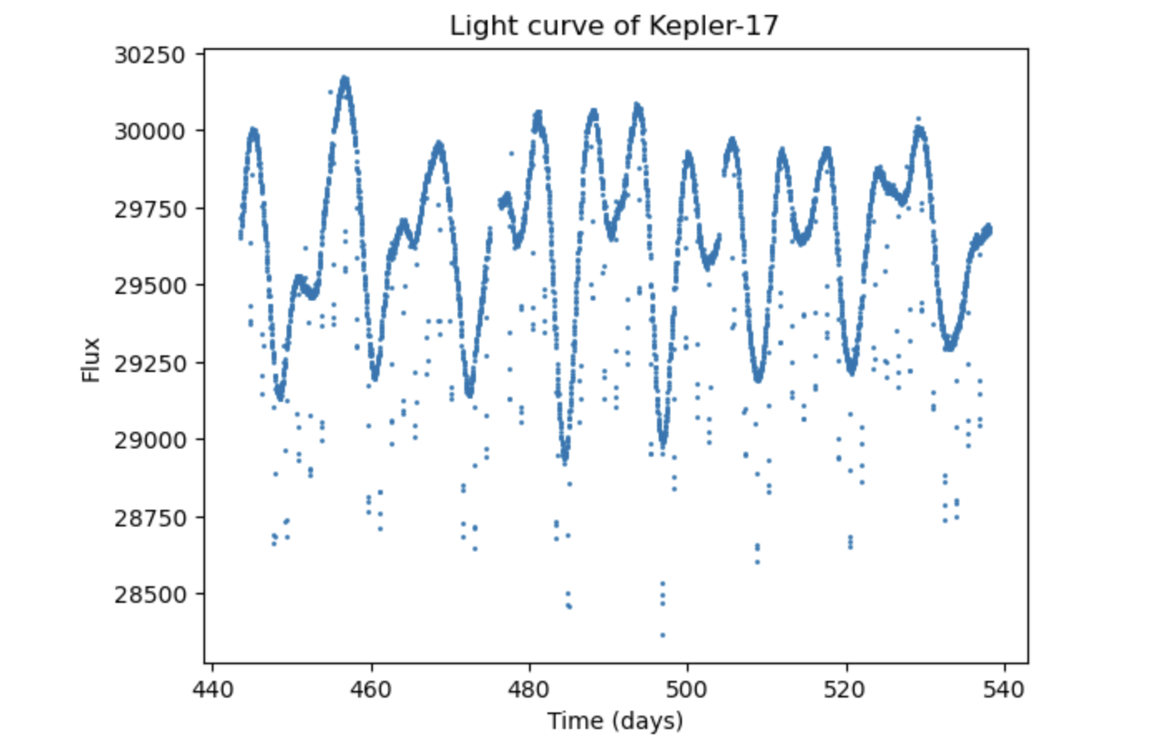
Two forms of variability were identified when analysing the light curve:

- Sharp periodic dips, meaning a planetary transit was occurring, resulting in a roughly constant reduction in flux from the star’s usual brightness at every transit, may vary due to starspots. This is due to the exoplanet having a constant radius and orbital distance, meaning the same quantity of light is blocked, unlike starspots, which can evolve and grow in size.

- Smooth quasi-periodic dips, meaning starspots were present on the stellar surface, resulting in the flux of the star decreasing as the starspots remain on the surface, and varying depending on whether the starspots evolve and disappear or rotate out of the observer’s perspective
Period determination:

A periodogram was computed using the box least squares algorithm, with estimates made at the specific peaks which indicated the orbital or rotational period of the transiting exoplanet, Kepler-17 b.
This was done by downloading the periodogram data from the NASA Exoplanet Archive and importing it into the programming language Python. The process was similar to that done for the light curve, as Matplotlib was used. However, Power was on the y-axis instead.

The graph, Figure 3, was analysed to identify which peaks would be for the orbital period of the exoplanet Kepler-17 b and for the rotational period of the star Kepler-17. The estimates that were made were completed by varying and adjusting where the vertical line was placed, until the line appeared to be in line with the peak.

Figure 3: A graph of a periodogram captured by the Kepler Space telescope, where power is presented as a function of time, with both axes in this graph being linear; the dashed lines indicate where the estimations were taken. Values of estimation were varied until vertical line appeared to be on the desired peaks. Red line for P_{orb}, and green line for P_{rot}.
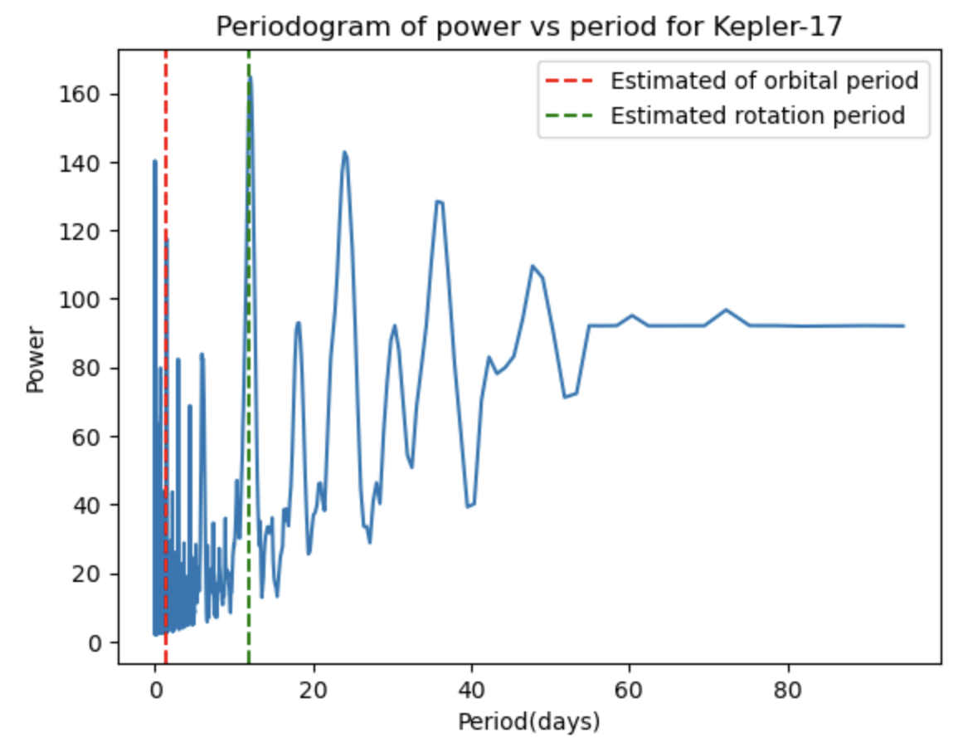
On this periodogram, a Gaussian function was fitted to the data points within a narrow range around the identified peak, to ensure accurate results and avoid mixing data from other peaks within a similar timeline.
The peak corresponding to the orbital period was strongest at roughly 1.5 days, being similar to the transit spacing that could be found on the light curve.
The peak corresponding to the rotation period was strongest at roughly 12 days, and the peak was similar to that found on the light curve.

The Gaussian function that was used to achieve an accurate estimation of P_{orb} and P_{rot}:

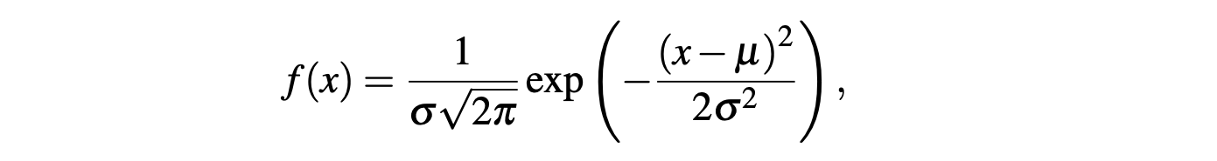

Using this equation and narrowing the values to be around the peak of the initial estimate, accurate values of P_{orb} and P_{rot} could be obtained on the graph in Figure 4. The uncertainties for the orbital and rotational period were taken as being the standard deviation from each Gaussian fit.

Figure 4: A graph of the Gaussian fit on the periodogram for both the orbital period and the rotational period, allowing for accurate values of P_{orb} and P_{rot}. The blue section shows the periodogram, and the orange section shows the Gaussian fit, with the min and max values being based around the estimation.

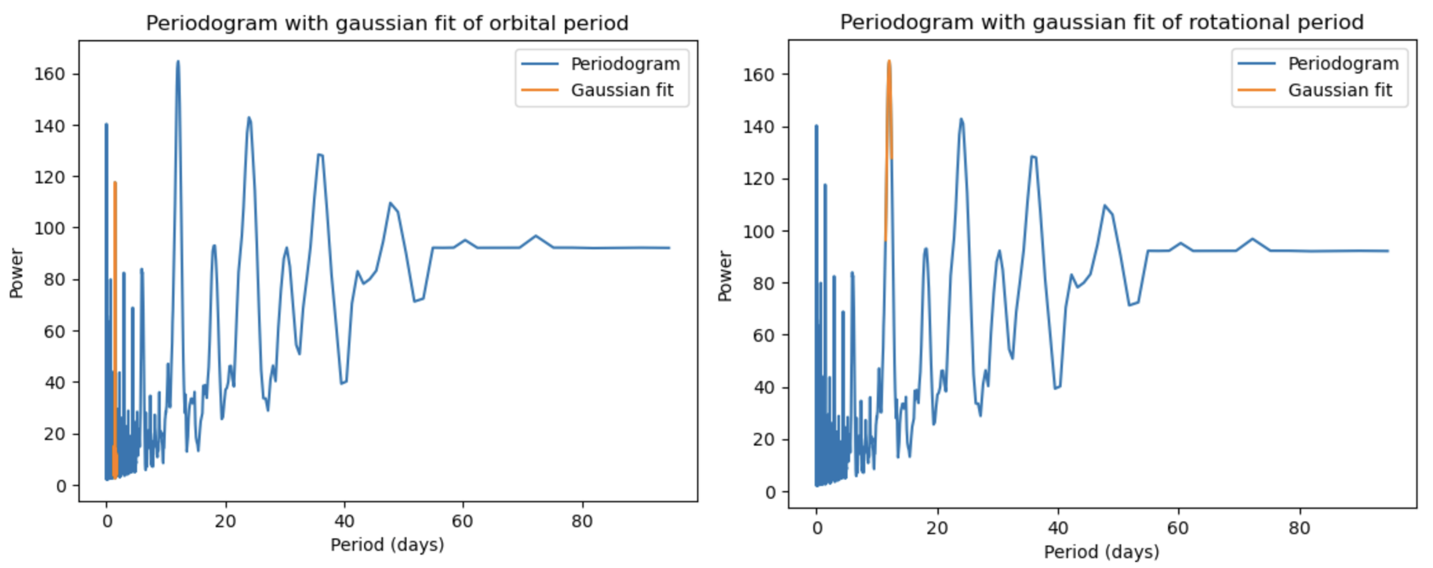

Using the Gaussian function from the periodogram allowed for an accurate value of the orbital period, P_{orb}, and the stellar rotation period, P_{rot}, that is consistent with the values published on the NASA Exoplanet Archive and the values in the Observations and data section of this paper.

Transit normalisation:

By normalising various transits on the light curve, an accurate transit depth would be able to be calculated, so that the exoplanet size can be measured accurately. Individual transit events were isolated to remove background noise and then normalised.

Individual transit events were taken from the light curve by selecting specific time intervals around the transit of the exoplanet when passing in front of the star Kepler-17. A linear function was fitted to the out-of-transit baseline, and each transit was normalised by dividing by this function, allowing for a graph to be produced, Figure 5.
By doing this, the stellar variability would be removed and ensure that accurate results of the transit depth could be determined.

Figure 5 : A graph of the normalisation of a transit section from a transit that occurs within the light curve, by normalising the background noise from starspots, could be removed, and an accurate estimation of the F_{dip} could be made. This graph was repeated 4 more times with other transit times.
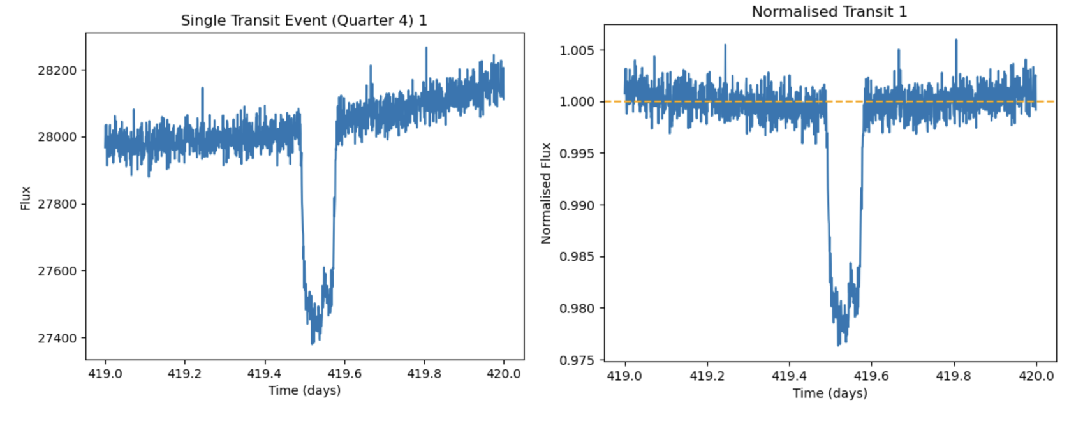
This process was completed on 5 different transits in order to maintain a suitable and accurate average result of F_{dip}. This process was completed by simply repeating the previous code that was used on the first transit, but varying when the transit would occur, such that multiple transit times would be taken. This was yet again completed in the programming language of Python.

Radius determination:
As various transits had been normalised, the various results of F_{dip} had been calculated, and this could then be used to calculate the radius ratio:
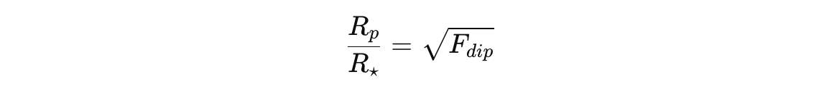
This then allowed for the uncertainty value to be calculated using standard error propagation.

Results

Light curve results:

When analysing the light curve, two clear observations could be made:
- Regular transit dips that indicated the existence of an orbiting exoplanet around the host star, causing a reduction in brightness as light was blocked by the exoplanet.

- Quasi-periodic dips that indicated the existence of star spots located on the stellar surface, which were forming, disappearing or entering and exiting our perspective of the star’s surface. These were at uneven intervals, meaning that these dips were indeed star spots and not an exoplanet transiting.

Periodogram results:
When analysing the periodogram, there were two dominant peaks which would indicate to the P_{orb} of the exoplanet that is transiting the star Kepler-17 b and P_{rot} of the star Kepler-17.

P_{orb} ≈ 1.4858 ± 0.0002 days
P_{rot} ≈ 12.0920 ± 0.0043 days

Additionally, the uncertainties of the peaks were obtained from the Gaussian fits around them.

Radius ratio:
In order to obtain the radius ratio between the exoplanet Kepler-17 b and Kepler-17, 5 different transit events were identified, normalised and used with the radius ratio equation involving F_{dip}.

Table 2: A table showing the results of F_{dip}, from the normalisation of specific transits that occurred during the light curve and the radius ratio value and its uncertainty of the exoplanet Kepler-17 b and the star Kepler-17 with the uncertainty.
Transit | F_{dip} | Rp​/R⋆​ | σ Rp​/R⋆​
1 | 0.9763 | 0.1538 | 0.0043
2 | 0.9770 | 0.1515 | 0.0043
3 | 0.9768 | 0.1522 | 0.0041
4 | 0.9759 | 0.1553 | 0.0058
5 | 0.9768 | 0.1522 | 0.0040
Mean value | - | 0.1530 | 0.0045

R_{p}/R⋆ = 0.1530 ± 0.0045

Discussion

The refined model, accounting for starspots for the transit method, allowed for successful values of the transit and stellar variability that would occur when measuring the brightness of a star. This resulted in accurate values of P_{orb} and P_{rot}, which agreed with the values on the NASA Exoplanet Archive.

The presence of starspots when measuring the brightness of the star Kepler-17 caused systematic uncertainty in the transit depth measurement. This is due to the stellar brightness not being constant, as there may always be starspots, this was mitigated via normalisation of the transits.

Potential sources of error within my values could be caused by:
- Noise within the photometric data provided by the NASA Exoplanet Archive
- An imperfect fitting of the normalisation
- Starspot evolution affects the brightness, as starspots evolve and disappear
However, the value of the radius ratio calculated was 17.4% different from the value from the NASA Exoplanet archive, suggesting that the calculation of the exoplanet Kepler-17 b's radius in this experiment was an overestimate and too large. This may have been due to the process used to isolate transits, and these transits may have contained star spots, which affected the maximum brightness observed. It could also be due to the normalisation of the transits being imperfect.

Conclusion
By accounting for starspots affecting the brightness of the star system Kepler-17, estimations were able to be made on various parameters of the star’s system.

The key findings of the system that were able to be identified from the flux data of the Kepler-17 star system, which had the exoplanet Kepler-17 b orbiting:
- P_{orb}, the orbital period of the exoplanet Kepler-17 b orbiting around its host star Kepler-17
- P_{rot}, the stellar rotation period of the host star Kepler-17
- The stellar variability caused by star spots on the stellar surface significantly affected the light curve interpretation
There was difficulty in finding a correct value for the radius ratio, which could have been caused by multiple issues, as stated in the Discussion section. As a result of this, an overestimation was calculated for the value, which was 17.4% larger than the accepted value.

References
- NASA Exoplanet Archive
- PHY1035_Astro1_exoplanets_II.pdf

Appendix

Code, The code used, some of this is shortened and lack of spaces and comments for simplification and to fit within the page limit:
Light curve:
# Astrolabs 2 - Transisting exoplanets
# 1.3
import numpy as np
Gaussian fit for the P_{rot}, similar code for P_{orb}, changed slightly
def gaussian(x, amp, mean, sigma):
return amp * np.exp(-0.5 * ((x - mean)/sigma)**2)
x_min = 11.5
x_max = 12.5
mask = (Period >= x_min) & (Period <= x_max)
x_subset = Period[mask]
y_subset = Power[mask]
params, cov = curve_fit(gaussian, x_subset, y_subset, p0=(160, 12.0, 0.3))
period_fit = params[1]
err_period = np.sqrt(cov[1,1])
print('Best-fit of the stellar rotation period =', period_fit, '+/-', err_period, 'days')
x_fit = np.linspace(x_min, x_max, 500)
y_fit = gaussian(x_fit, *params)
fig, ax = plt.subplots()
ax.plot(Period, Power, label='Periodogram')
ax.plot(x_fit, y_fit, label='Gaussian fit')
ax.set_xlabel('Period (days)')
ax.set_ylabel('Power')
ax.set_title('Periodogram with gaussian fit of rotational period')
ax.legend()
plt.show()
import matplotlib.pyplot as plt
#use loadtxt to load in the data
data = np.loadtxt('lightcurve_kepler17_quarter5.tbl', skiprows = 3)
# identify the data, 2nd column is time, 3rd column is flux
time = data[:, 1]
flux = data[:, 2]
fig, ax=plt.subplots()
ax.set_xlabel('Time (days)')
ax.set_ylabel('Flux')
ax.set_title('Light curve of Kepler-17')
ax.plot(time,flux,'.', markersize=2)
plt.show()

Periodogram estimate:
# 2.2
content=np.loadtxt('periodogram_kepler17_quarter5.tbl',skiprows =3)
Period = content[:, 1]
Power = content[:, 2]

fig, ax=plt.subplots()
ax.plot(Period,Power)
ax.set_xlabel('Period(days)')
Code for selecting individual transit
quarter4_data = np.loadtxt('transit_kepler17_quarter4.tbl', skiprows = 3)
time_arr = quarter4_data[:, 1]
flux_arr = quarter4_data[:, 2]
t_start1 = 419 t_end1 = 420
mask1 = (time_arr >= t_start1) & (time_arr <= t_end1)
time_arr_transit1 = time_arr[mask1]
flux_arr_transit1 = flux_arr[mask1]
fig, ax = plt.subplots()
ax.plot(time_arr_transit1, flux_arr_transit1)
ax.set_xlabel('Time (days)')
ax.set_ylabel('Flux')
ax.set_title('Single Transit Event (Quarter 4) 1'). plt.show()
ax.set_ylabel('Power')
ax.set_title('Periodogram of power vs period for Kepler-17')

# estimated peaks from earlier tasks
ax.axvline(1.52, linestyle='--', label='Estimated of orbital period', color='r')
ax.axvline(12, linestyle='--', label='Estimated rotation period', color = 'g')
ax.legend()
plt.show()

Code for normalising the transit
t_dip_start1 = 419.48. t_dip_end1 = 419.58
mask_out1 = (time_arr_transit1 < t_dip_start1) | (time_arr_transit1 > t_dip_end1)
time_out1 = time_arr_transit1[mask_out1]. flux_out1 = flux_arr_transit1[mask_out1]
m1, c1 = np.polyfit(time_out1, flux_out1, 1)
f_t1 = m1 * time_arr_transit1 + c1. flux_norm1 = flux_arr_transit1 / f_t1
fig, ax=plt.subplots()
ax.plot(time_arr_transit1, flux_norm1)
ax.axhline(1.0, linestyle='--', color= 'orange') ax.set_xlabel('Time (days)'). ax.set_ylabel('Normalised Flux'). ax.set_title('Normalised Transit 1')
flux_norm_out1 = flux_norm1[mask_out1]
sigma_norm1 = np.std(flux_norm_out1). flux_uncertainty1 = sigma_norm1 / f_t1
F_dip1 = np.min(flux_norm1). F_dip_error1 = sigma_norm1
print("Standard deviation (normalised flux) =", sigma_norm1) print("F_dip =", F_dip1)
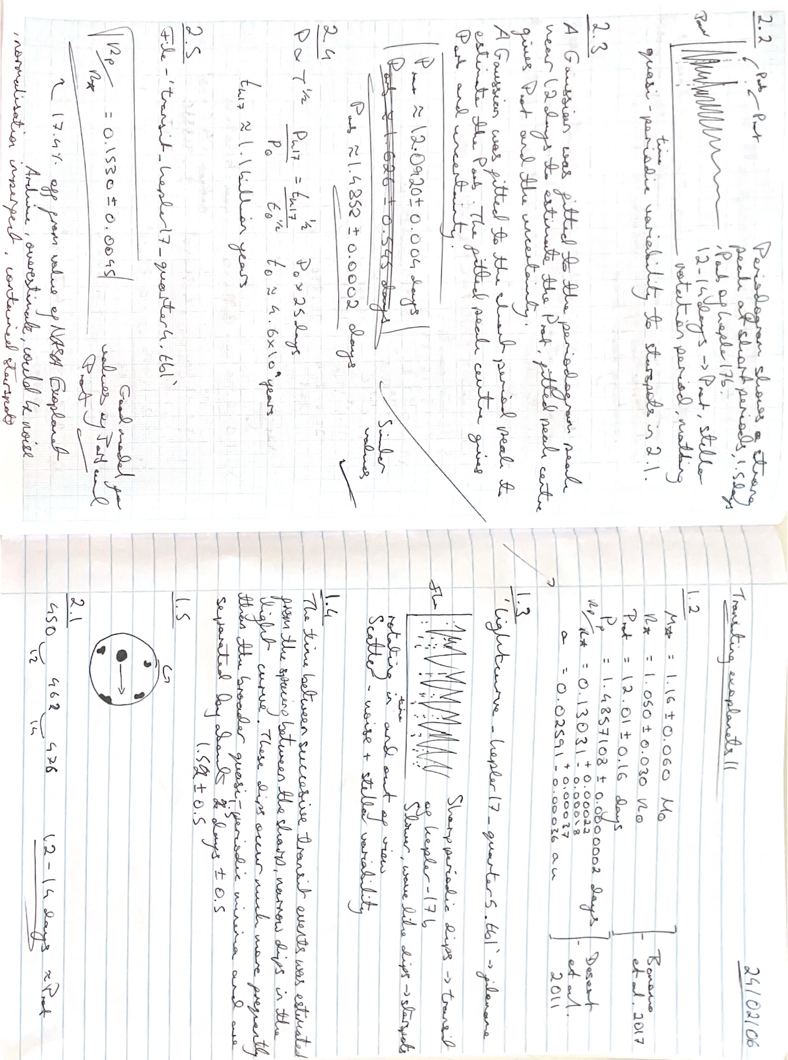
Lab book notes, written whilst completing the experiment:

